WALMART RETAIL ANALYSIS BETWEEN 2020-2023
Abstract:
This project demonstrates a complete analytics pipeline using Python, SQL, and Power BI to analyze Walmart’s retail sales between 2020 and 2023. The goal was to uncover performance trends, store efficiency, promotional impact, and external drivers, and to provide actionable business recommendations. The project highlights technical mastery, data storytelling, and decision-oriented insights.
Dataset summary:
1. Features Dataset
  - Shape: 8,190 rows × 12 columns
  - Columns: Store, Date, Temperature, Fuel Price, MarkDown1–5, CPI, Unemployment, etc.
  - Missing Values:
  - MarkDown1: 4,032 non-null → ~50% missing
  - MarkDown2: 2,921 non-null → ~64% missing
  - MarkDown3: 3,613 non-null → ~56% missing
  - MarkDown4: 3,464 non-null → ~58% missing
  - MarkDown5: 4,028 non-null → ~51% missing
  - CPI & Unemployment: some missing (~10–15%)
  - Temperature & Fuel Price: complete (no missing)
- Stores Dataset
  - Shape: 45 rows × 3 columns
  - Columns: Store, Type (A/B/C), Size
  - Missing Values: None
- Train Dataset
  - Shape: 421,570 rows × 5 columns
  - Columns: Store, Dept, Date, Weekly_Sales, IsHoliday
  - Missing Values: None (clean transactional data)
- Test Dataset
- Shape: 115,064 rows × 4 columns
- Columns: Store, Dept, Date, IsHoliday
- Missing Values: None
Exploratory data analysis using python:
• Markdowns: Missing values replaced with 0 (no promotion).
- CPI & Unemployment: Filled using forward/backward fill.
- Fuel Price & Temperature: Complete, but smoothed with rolling averages.
- Validation: Checked for duplicates, ensured consistency across stores/departments
Combined Dataset Structure
After merging, created train_full and test_full datasets with rich features:
- Train_Full:
  - Rows: 421,570
  - Columns: 17
  - Includes: Store, Dept, Date, Weekly_Sales, IsHoliday, Store Type, Size, Temperature, Fuel Price, MarkDown1–5, CPI, Unemployment.
- Test_Full:
- Rows: 115,064
- Columns: 16
- Includes: Store, Dept, Date, IsHoliday, Store Type, Size, Temperature, Fuel Price, MarkDown1–5, CPI, Unemployment.
SQL Analysis Summary
Database Setup
- Created a database WALMART and loaded merged datasets (train_full, test_full).
- Verified schema with DESCRIBE commands to confirm column structures.
- Ensured data integrity by checking row counts and sample records.
Key Queries & Insights
- Total Weekly Sales by Store
Showed overall contribution of each store to total revenue.
- Top 5 Stores by Sales
Identified Store 20, 4, 14, 13, and 2 as leaders.
- Holiday vs Non-Holiday Sales
Holiday weeks contributed ~7.5% of total sales.
- Average Holiday Sales per Store
Showed which stores benefited most from holiday demand.

- Sales by Store Type
Type A stores dominated revenue, confirming efficiency.
- Fuel Price & Temperature Impact

Queries grouped by Fuel_Price and Temperature revealed negative
correlation with sales.

- Markdown Effectiveness
Demonstrated promotions’ positive impact on weekly sales.
- Trend Analysis (Monthly & Yearly)
Showed growth in 2021 (+6.96%) and decline in 2022 (−18.3%), with Q4 2022 anomaly.

- Department Performance
Identified top-performing departments within stores.

- Economic Factors (Unemployment & CPI)
Higher unemployment and CPI correlated with reduced sales.
Power BI Integration Summary
Connection Setup
- Connected the Walmart SQL database (train_full, test_full) directly into Power BI.
- Verified schema mapping: Store, Dept, Date, Weekly_Sales, Holiday Flag, Store Type, Size, Temperature, Fuel Price, MarkDown1–5, CPI, Unemployment.
- Established relationships between tables (Store ID, Date) for seamless filtering
Dashboard Pages
Page 1 – Performance Overview
- Total Sales: ₹6.74B across 2020–2023.
- Holiday vs Non-Holiday: Holiday weeks contributed ₹505M (7.5%), non-holiday ₹6.23B (92.5%).
- Year-over-Year Trends:
  - 2021 grew +6.96% vs 2020.
  - 2022 declined −18.3% vs 2021 due to Q4 drop.
- Quarterly Breakdown: Q4 2022 anomaly (₹0.18B vs ~₹0.6B in other quarters).
- Average Sales per Store: ₹149.72M.
- Sales per SqFt: ₹49.27K.
- Top 5 Stores: Store 20, 4, 14, 13, 2.
- Filters: Year, Holiday Flag, Store, Type, Dept slicers for drill-downs.
- Visuals: Line charts for trends, bar charts for store comparison.
- Business Signal: Answers “What happened?” with KPIs and anomalies.

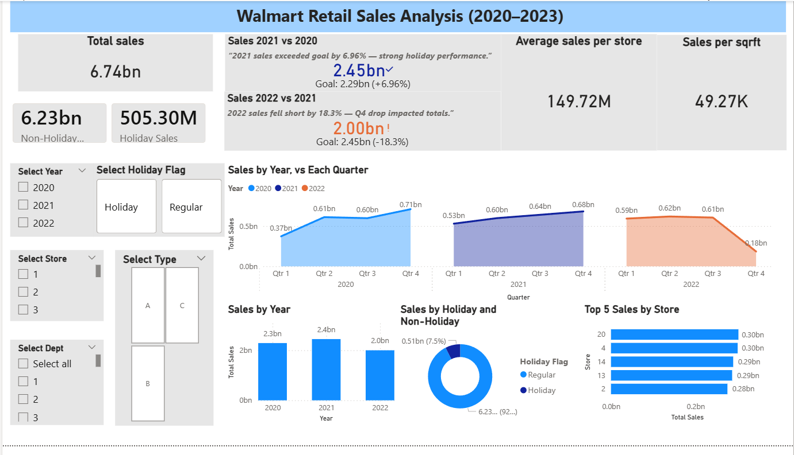

Page 2 – Drivers & Store Efficiency
Overview
This dashboard analyzes store efficiency, promotional impact, and external drivers across Walmart’s store formats (Type A, B, C). It combines SQL-derived metrics with Power BI visuals to provide a clear picture of what drives weekly sales.
Key Metrics
- Store Type Efficiency:
  - Type A: ₹23,766 per SqFt, Avg Sales per Store ~₹196.86M, Total Sales ₹4.33B.
  - Type B: ₹19,649 per SqFt, Avg Sales per Store ~₹117.68M, Total Sales ₹2.00B.
  - Type C: ₹10,003 per SqFt, Avg Sales per Store ~₹67.58M, Total Sales ₹40.55M.
  - Type A stores dominate efficiency and revenue.
- Store Count: 21 Type A, 17 Type B, 4 Type C.
- Sales Contribution: Type A stores generated ~64% of total sales.
- Markdown Impact: Scatter plots show positive correlation between markdowns and weekly sales, especially in Type A stores.
- Fuel Price Effect: Higher fuel prices correlate with reduced weekly sales, indicating consumer sensitivity.
- Unemployment Effect: Higher unemployment rates correlate with lower weekly sales, showing macroeconomic influence.
- Scatter Plots:
  - Fuel Price vs Weekly Sales.
  - Unemployment vs Weekly Sales.
  - Markdown vs Weekly Sales.
- Visuals:
  - Bar chart: Sales per SqFt by store type.
  - Efficiency table: Store type breakdown.
  - Interactive slicer: Markdown1–5 selection.
- Business Signal: This page answers “Why did it happen?” by linking store efficiency, promotions, and external drivers to sales outcomes.
- Actionable Insight: Type A stores are the backbone of Walmart’s portfolio, while Type C stores underperform significantly. Promotions and external conditions must be closely monitored to sustain growth.
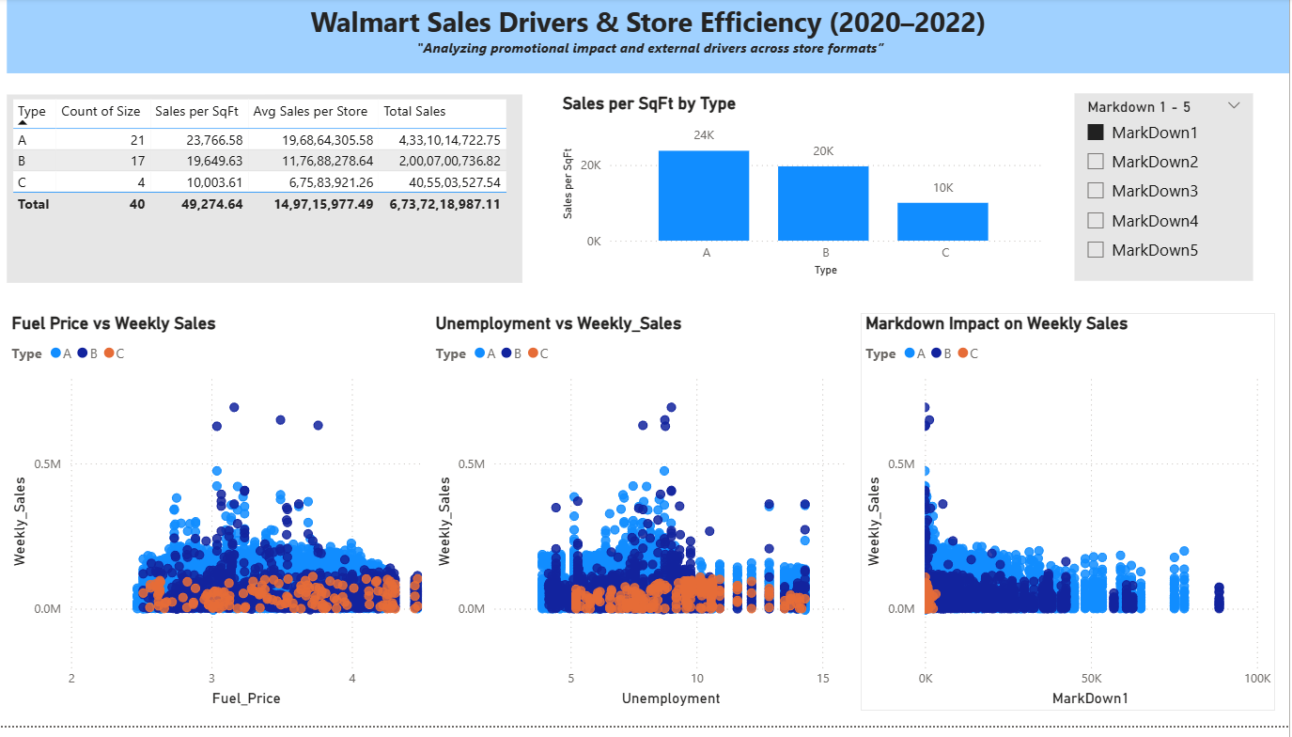

Conclusion
This project demonstrates a complete end-to-end analytics pipeline for Walmart’s retail sales data (2020–2023). Starting with Python for data cleaning and preprocessing, the datasets were merged and structured in SQL, enabling efficient querying and KPI extraction. Power BI was then used to transform these results into interactive dashboards that highlight performance trends, store efficiency, promotional impact, and external drivers.
The analysis revealed clear patterns:
- Holiday weeks consistently drive seasonal spikes in sales.
- Type A stores deliver the highest efficiency and revenue contribution, while Type C stores underperform.
- Markdown promotions positively influence weekly sales, though effectiveness varies by store type.
- External drivers such as fuel prices and unemployment significantly affect consumer demand.
- A major anomaly occurred in Q4 2022, where sales dropped sharply, highlighting vulnerability to external conditions.
This project not only showcases technical mastery across Python, SQL, and Power BI but also emphasizes business storytelling — turning raw data into actionable insights for decision-makers.
Recommendations
- Optimize Store Portfolio
  - Expand and invest in Type A stores (highest ROI).
  - Reassess or restructure Type C stores to improve efficiency.
- Strategic Promotions
  - Focus markdowns on high-performing stores and holiday periods.
  - Avoid over-discounting in low-efficiency formats.
- Monitor External Drivers
  - Track fuel prices and unemployment trends to forecast demand.
  - Adjust inventory and staffing based on macroeconomic conditions.
- Holiday Planning
  - Align promotions, inventory, and staffing with seasonal spikes.
  - Use predictive analytics to anticipate holiday demand more accurately.
- Benchmark Top Stores
  - Identify success factors in top-performing stores (Store 20, 4, 14, 13, 2).
  - Replicate best practices across underperforming locations.
- Enhance Forecasting
- Incorporate machine learning models for demand prediction.

